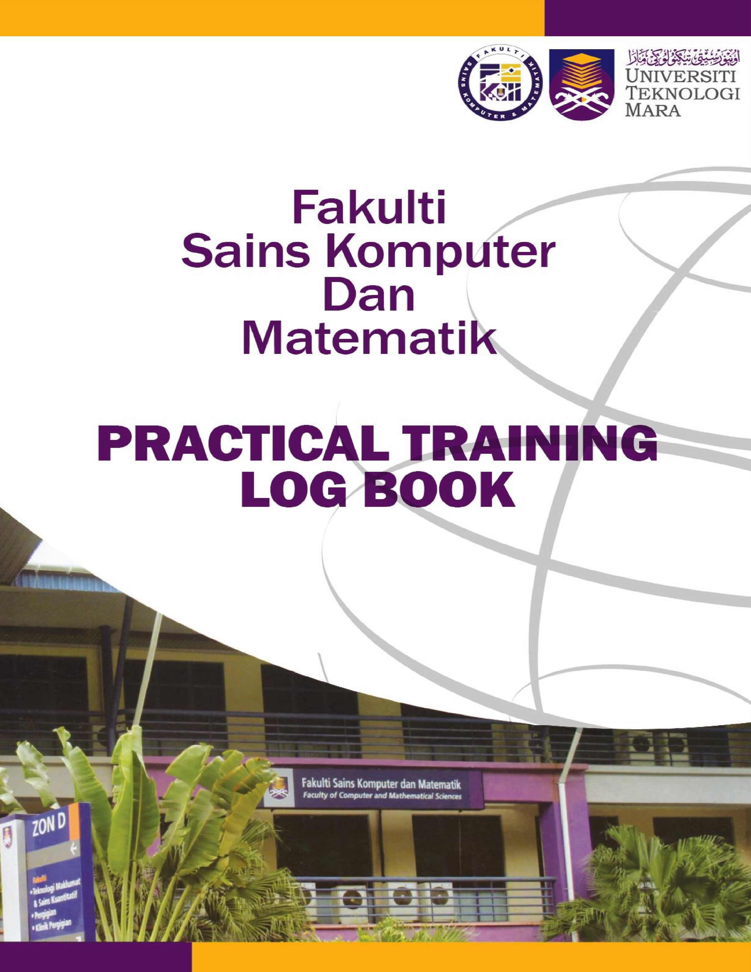

**Instructions**

This book is issued to you to provide a history of your training and to act as a weekly record by the work on which you are engaged.

# Student’s responsibilities for keeping log book up-to-date

Immediately this book is issued to you, you should, I consultation with your Training Officer, complete the details required on the previous page.

It is your responsibility to make the main entries of the log book and keep it up to date. Entries must be regularly initialed by your Supervisor. You must ensure that;

1. It is available at your place of work during your training.
2. All entries, except sketches, are made in ink.
3. Entries are made within a week of the work to which they refer.
4. The book is handed to your Training Officer for retention on your return to UiTM and this will later be handed to the Head of School for grading.

# Recording

The log book should contain the following information.

1. A neat concise description of each of your training location and the work on which you are engaged.
2. Relevant sketches, data and circuit diagrams.
3. References to textbooks, standards and other technical information related to the work being under taken.
4. Constructive comments on the work being undertaken and your considered opinion as to its value as training.

1. Student’s name: Siti Balqis Binti Mohd Khairi

2. Date & Place of Birth: 19 June 2000 / Hospital Batu Pahat

1. UiTM I/C No: 000619-01-1628
2. Course: Bachelor of Information Technology (Hons.) Information Systems Engineering
3. Year: 2019-2023

6. Home address: No 1, Kampung Parit Raja Ahmad, 83500 Parit Sulong, Batu Pahat, Johor

1. Address during practical training:

No 1, Kampung Parit Raja Ahmad, 83500 Parit Sulong, Batu Pahat, Johor

1. Place of training:

KPJ Specialist Hospital, No 1, Jalan Mutiara Gading 1 Taman Mutiara Gading Sri Gading, 83000 Batu Pahat, Johor

1. Name of Supervisor in-charge: Mr Majid Bin Omar
2. Duration of training: From: 2nd October 2022 to 16th October 2023

# FOR OFFICE USE ONLY

11. Remarks: (Dean/Course Tutor)

________________________________________________________________________

________________________________________________________________________

________________________________________________________________________

________________________________________________________________________

________________________________________________________________________

________________________________________________________________________

|  |  |  |
| --- | --- | --- |
| DATE | EXACT NATURE OF WORK DONE | SUPERVISORS REMARKS |
| 2.10.2022 | - Briefing about job scope during internship period |  |
| 3.10.2022 | - Set up monitor and pc for work use.  - Installing and setup new software into the device that will be used. |  |
| 4.10.2022 | - Briefing and planning for software development (IT asset system). |  |
| 5.10.2022 | - Planning for software development (IT asset system).  - Record asset in hospital for project requirement. |  |
| 6.10.2022 | - Planning for software development (IT asset system).  - Record asset in hospital for project requirement. |  |
| 7.10.2022 | - Planning and analysing requirement for software development (IT asset system)  - Record asset in hospital for project requirement. |  |
| 9.10.2022 | - Public Holiday (Maulidur Rasul) |  |
| 10.10.2022 | - Starting for development of IT asset system  - Record asset in hospital for project requirement. |  |
| 11.10.2022 | - Starting for design and development of IT asset system. |  |
| 12.10.2022 | - Design and development of IT asset system. |  |
| 13.10.2022 | - Involve in 5S Internal Audit by Malaysia Productivity Corporation (PMC). |  |
| 14.10.2022 | - Involve in 5S Audit by Malaysia Productivity Corporation.  - Designing floor plan for IT department. |  |
| 16.10.2022 | - Participate in 3rd Anniversary KPJ Batu Pahat, Pink October and HR Open Day. |  |
| 17.10.2022 | - Design and development of IT asset system.  - Continue record data for IT asset. |  |
| 18.10.2022 | - Design and development of IT asset system. |  |
| 19.10.2022 | - Design and development of IT asset system. |  |
| 20.10.2022 | - Involve in Gotong- Royong Mega (Preparation for External Audit) |  |
| 21.10.2022 | - Design and development of IT asset system. |  |
| 23.10.2022 | - Design and development of IT asset system. |  |
| 24.10.2022 | - Public Holiday ( Deepavali Day) |  |
| 25.10.2022 | - Involve in preparation for external audit 5S |  |
| 26.10.2022 | - Involve in external audit 5S by MPC.  - Continue collecting data for asset and clean up all devices. |  |
| 27.10.2022 | - Continue collecting data for asset and clean up all devices. |  |
| 28.10.2022 | - Continue collecting data for asset and clean up all devices. |  |
| 30.10.2022 | - Continue collecting data for asset and clean up all devices. |  |
| 31.10.2022 | - Design and development of IT asset system.  - betulkan mesin printer? Connect dgn server? |  |
| 1.11.2022 | - Feedback session with team for system’s interface.  - Recollecting requirements for system’s functions. |  |
| 2.11.2022 | - Start updating the systems requirement and re-designing the interface. |  |
| 3.11.2022 | - Start updating the systems requirement and re-designing the interface.  - Start coding. |  |
| 4.11.2022 |  |  |
| 6.11.2022 |  |  |
| 7.11.2022 |  |  |
| 8.11.2022 |  |  |
| 9.11.2022 |  |  |
| 10.11.2022 |  |  |
| 11.11.2022 |  |  |
| 13.11.2022 | - claim cuti peristiwa jdt win |  |
| 14.11.2022 |  |  |
|  |  |  |
|  |  |  |
|  |  |  |
|  |  |  |
|  |  |  |
|  |  |  |
|  |  |  |
|  |  |  |
|  |  |  |
|  |  |  |
|  |  |  |
|  |  |  |
|  |  |  |
|  |  |  |
|  |  |  |
|  |  |  |
|  |  |  |
|  |  |  |
|  |  |  |
|  |  |  |
|  |  |  |
|  |  |  |
|  |  |  |
|  |  |  |
|  |  |  |
|  |  |  |
|  |  |  |
|  |  |  |
|  |  |  |
|  |  |  |
|  |  |  |
|  |  |  |
|  |  |  |
|  |  |  |
|  |  |  |
|  |  |  |
|  |  |  |
|  |  |  |
|  |  |  |
|  |  |  |
|  |  |  |
|  |  |  |
|  |  |  |
|  |  |  |
|  |  |  |
|  |  |  |
|  |  |  |
|  |  |  |
|  |  |  |
|  |  |  |
|  |  |  |
|  |  |  |
|  |  |  |
|  |  |  |
|  |  |  |
|  |  |  |
|  |  |  |
|  |  |  |
|  |  |  |
|  |  |  |
|  |  |  |
|  |  |  |
|  |  |  |
|  |  |  |
|  |  |  |
|  |  |  |
|  |  |  |
|  |  |  |
|  |  |  |
|  |  |  |
|  |  |  |
|  |  |  |
|  |  |  |
|  |  |  |
|  |  |  |
|  |  |  |
|  |  |  |
|  |  |  |
|  |  |  |
|  |  |  |
|  |  |  |
|  |  |  |
|  |  |  |
|  |  |  |
|  |  |  |
|  |  |  |
|  |  |  |
|  |  |  |
|  |  |  |
|  |  |  |
|  |  |  |
|  |  |  |
|  |  |  |
|  |  |  |
|  |  |  |
|  |  |  |
|  |  |  |
|  |  |  |
|  |  |  |
|  |  |  |
|  |  |  |
|  |  |  |
|  |  |  |
|  |  |  |
|  |  |  |
|  |  |  |
|  |  |  |
|  |  |  |
|  |  |  |
|  |  |  |
|  |  |  |
|  |  |  |
|  |  |  |
|  |  |  |
|  |  |  |
|  |  |  |
|  |  |  |
|  |  |  |
|  |  |  |
|  |  |  |
|  |  |  |
|  |  |  |
|  |  |  |
|  |  |  |
|  |  |  |
|  |  |  |
|  |  |  |
|  |  |  |